Capstone Planning Document

## Description:

For my Capstone Project, I will be building an interactive horror experience. As the requirement for the capstone project was building an experience that makes the player feel some emotion, I chose fear. For reference, here is a short explanation of the experience called VRScare:

*Watching short horror movies can easily scare anyone but when they are seen in VR, it’s a whole another feel.*

*Playing scary games has never been so scary. VR has brought a whole new way of experiencing fear.*

To begin the experience, viewers will see a UI with the title VRScare and a short description of the experience. Users can click on the button to get an option of either watching scary videos or play the fear game.

If you choose the movie option, you get blocks of various movies to choose from and the movie you select starts playing on the screen in front of you. You get options to pause, play, rewind, seek, mute or play next video. These videos are being streamed online.

If you choose the game option, you have to escape the asylum in level one. There are two doors, both of them are locked. There is a zombie AI agent that moves on a fixed waypoint route. If the zombie finds you, you die and lose the game. You have to find the key and get out of the exit door. The entry door won’t work. Once you are out of that door, the time you took, in seconds is displayed. You can play the next level, Zombie’s revenge. This level is harder as there are 4 doors in total and a larger setup. This won’t be an asylum and there are going to be more walkable AIs attacking the player. Only one out of the four doors is the exit door.

## Features And Dependencies:

### Models and Scripts

* 1. Zombie Model and Animation –

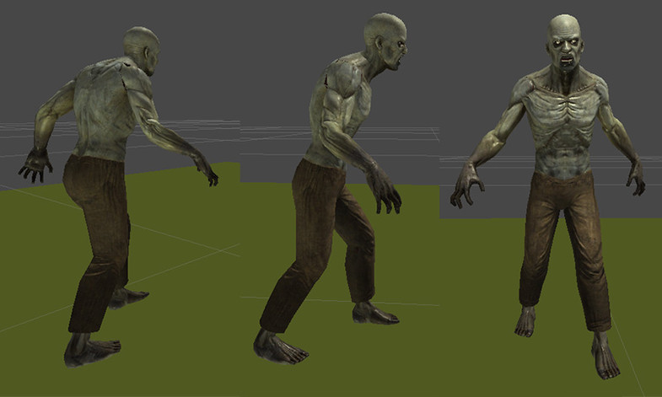

* 1. Scarecrow

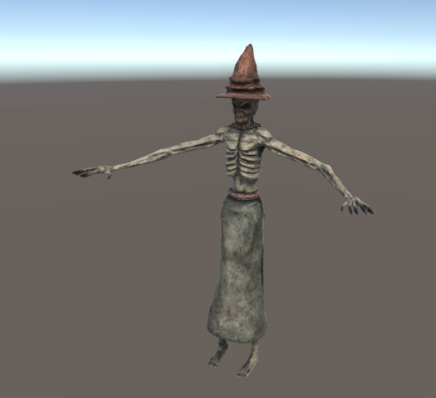

* 1. Skeleton

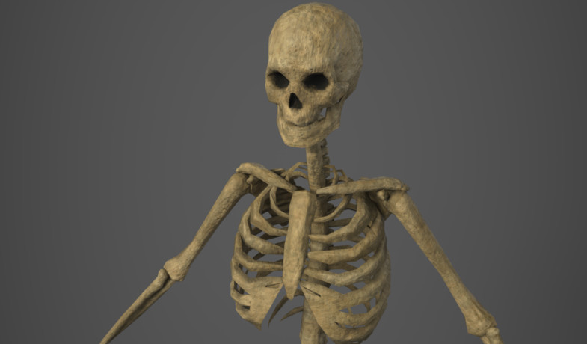

* 1. Skybox



* 1. Hospital Horror Pack

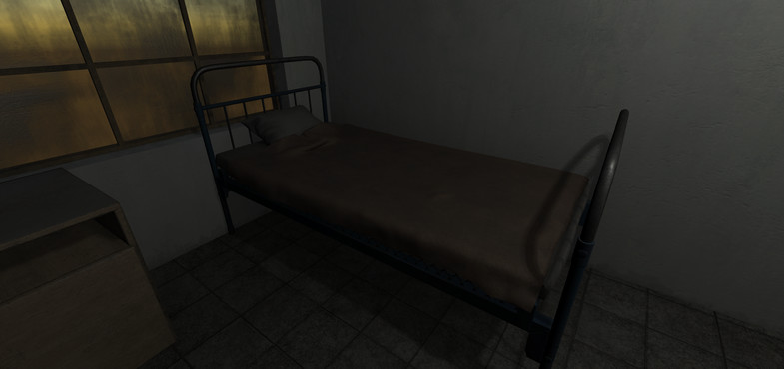

* 1. Door

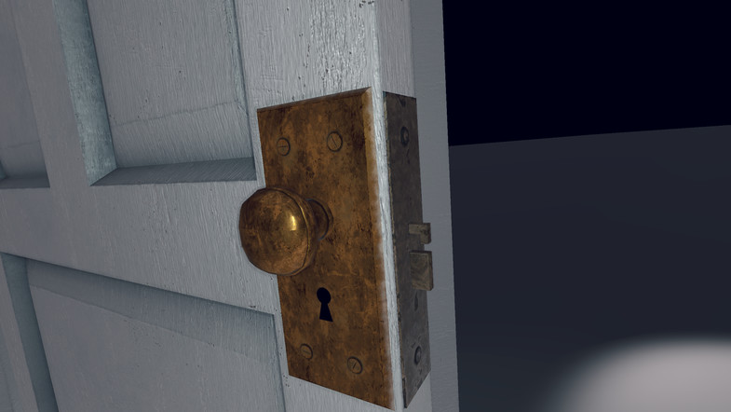

* 1. Stoned Wall

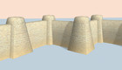

* 1. Fortress Gate

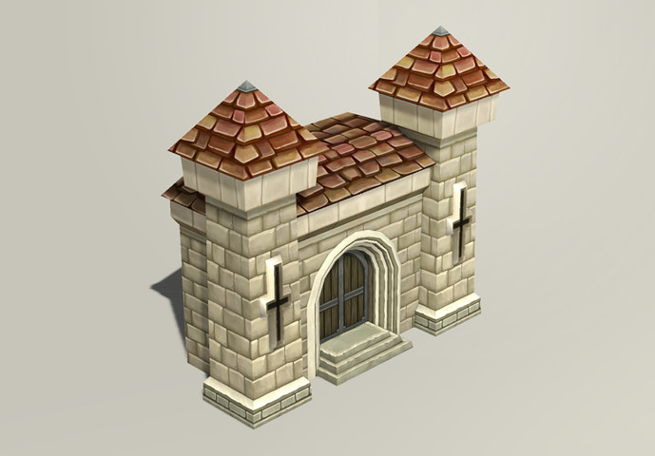

* 1. RAIN AI
  2. Rapid Waypoint System
  3. Waypoints
  4. Keys
  5. iTween
  6. Chibbi Mummy
  7. GazeUI
  8. AVPro Video

### Game Loop

* 1. General UI functions
  2. Clickable Waypoints for Movement
  3. Game Mechanic or AI for Zombie/Scarecrow/Skeleton Movement
  4. Video player integration
  5. Light iTween movements

### Other Effects

* 1. Particle System for Key collection
  2. Spatial Audio Sounds to make experience more scary
  3. Spatial sound for zombie/scarecrow/skeleton
  4. Waypoint route/Navigation mesh for enemy

Capstone Scoping

## Features and Dependencies:

### Models and Scripts

* 1. Zombie Model and Animation:

**Revised:** Will just use Walk and Attack animation and fix the shader to Mobile-unlit to improve FPS.

* 1. Scarecrow:

**Revised:** Will not use scarecrow as adding animation breaks the prefab the scarecrow starts acting weird.

* 1. Skeleton:

**Revised:** Will not animate skeleton and just make it static as the prefab breaks after animation. Also fixed the shader to Mobile-unlit to improve FPS. Will not use this as an AI agent but just a static prop.

* 1. Hospital Horror Pack:

**Revised:** Changed the shader to Mobile-unlit for all prefabs. Doubled the wall prefab so that the wall is reflective on both ends.

* 1. Door

**Revised:** Changed the shader to Mobile-unlit to improve FPS. Removed animation as not required.

* 1. Stoned Wall

**Revised:** Changed the scale to fit the scene. Changed the shader to mobile-unlit.

* 1. Fortress Gate

**Revised:** Just need the gate as the fortress walls don’t go with the rest of the stone walls.

* 1. RAIN AI

**Revised:** Would use Unity Navigation Mesh and simple NavMesh agent instead. RAIN AI is not really required for the game.

* 1. Rapid Waypoint System

**Revised:** Very tasking for the performance so won’t be using it.

* 1. Waypoints

**Revised:** The original script wasn’t working with latest GVR for Unity so made some changes in the script.

* 1. Keys

**Revised:** Changed the shader and material to look scarier.

* 1. Chibbi Mummy

**Revised:** Tasking animation so removed the model altogether.

* 1. GazeUI

**Revised:** Won’t be using this as the game is already heavy.

* 1. AVPro Video

**Revised:** Just used a 2D video.

### Game Loop

* 1. Game Mechanic or AI for Zombie/Scarecrow/Skeleton Movement

**Revised:** Instead of using a proper behavior tree based AI, just used unity navmesh and navmesh agent. Programmed zombie to follow the camera.

* 1. Video player integration.

**Revised:** Instead of going with a grid of videos, just added one video player that plays two videos by using simple Video Control script by AVPro Video.

* 1. Light iTween movements

**Revised:** Used onstart and oncomplete functions so that the zombie doesn’t start unless the game has started.

### Other Effects

* 1. Spatial sound for zombie/scarecrow/skeleton

**Revision: Added different sounds instead of same sounds to all the zombies**

* 1. ~~Waypoint route~~/Navigation mesh for enemy

**Revision: Just used Unity NavMesh instead of RAIN AI.**